|  |  |  |  |
| --- | --- | --- | --- |
| **SRNO** | ***INDEX*** | **PAGENO.** | **REMARK** |
| ***1.*** | ***Aknowledgement*** |  |  |
| ***2.*** | ***Objective of the project*** |  |  |
| ***3.*** | ***Proposed System*** |  |  |
| ***4.*** | ***System Development Life Cycle*** |  |  |
| ***5.*** | ***Flow Chart*** |  |  |
| ***6.*** | ***Source Code*** |  |  |
| ***7.*** | ***Output*** |  |  |
| ***8.*** | ***Bibliography*** |  |  |

***ACKNOWLEDGEMENT***

***Apart from the efforts of me, the success of any project depends largely on the encouragement and guidelines of many others. I take this opportunity to express my gratitude to the people who have been instrumental in the successful completion of this project.***

***I express my deep sense of gratitude to the luminary The Principal Mam, Narayana Vidyalayam School, Chandrapur who has been continuously motivating and extending their helping hand to us.***

***I express my sincere thanks to the academician The Vice Principal, for constant encouragement and the guidance provided during this project***

***My sincere thanks to Mrs. Sarika Muley, Miss-In-charge. A guide. Mentor all the above a friend, who critically reviewed my project and helped in solving each and every problem, occurred during implementation of the project***

***The guidance and support received from all the members who contributed and who are contributing to this project, was vital for the success of the project. I am grateful for their constant support and help.***

**PROJECT ON GROCERY SHOP MANAGEMENT SYSTEM**

***INTRODUCTION***

***This software is used to maintain the shop customerdetail , product , details , workerdetails maintain the shop in updated and maintain records of in and out data shop***



***OBJECTIVES OF THE PROJECT***

*The objective of this project is to let the students apply the programming knowledge into a real -world situation /problem and exposed the students how programming skills helps in developing a good software .*

1. *Write program utilizing modern software tools .*
2. *Apply object oriented programming principles effectively when developing small to medium sized projects.*
3. *Write effective procedural code to small to medium sized problems .*
4. *Students will demonstrate a breadth of knowledge in computer science ,as exemplitied in areas of system , theory and software development .*
5. *Students will demonstrate ability to conduct a research or applied Computer Science project , requiring writing and presentation skills which exemplify scholarly style in computer science .*

***PROPOSED SYSTEM***

***Today one cannot afford to rely on the fallible human beings of be really wants to stand against today's merciless competition where not to wise saying "to err is human" no longer valid, it's outdated to rationalize your mistake. So, to keep pace with time, to bring about the best result without malfunctioning and greater efficiency so to replace the unending heaps of flies with a much sophisticated hard disk of the computer.***

***One has to use the data management software. Software has been an ascent in atomization various organisations. Many software products working are now in markets, which have helped in making the organizations work easier and efficiently. Data management initially had to maintain a lot of ledgers and a lot of paper work has to be done but now software product on this organization has made their work faster and easier. Now only this software has to be loaded on the computer and work. can be done.***

***This prevents a lot of time and money. The work becomes fully automated and any information regarding the organization can be obtained by clicking the button. Moreover, now it's an age of computers of and automating such an organization gives the better look.***

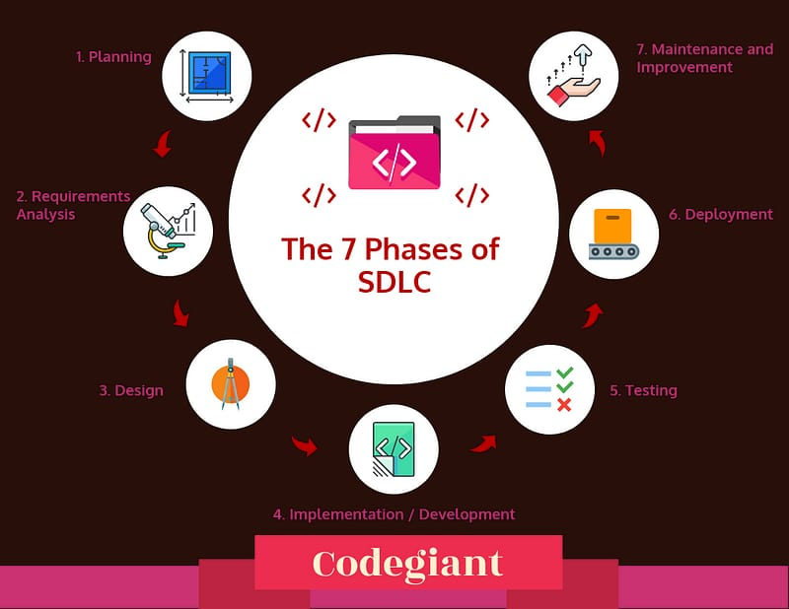***The systems development life cycle(SDLC)***

***The systems development life cycle is a project management technique that divides complex projects into smaller, more easily managed segments or phases. Segmenting projects allows managers to verify the successful completion of project phases before allocating resources to subsequent phases.***

***Software development projects typically include initiation, planning, design, development, testing, implementation, and maintenance phases. However, the phases may be divided differently depending on the organization involved.***

***For example, initial project activities might be designated as request. requirements-definition, and planning phases, or initiation, concept-development, and planning phases. End users of the system under development should be involved in reviewing the output of each phase to ensure the system is being built to deliver the needed functionality.***

FLOW CHART



